Employment Center Dashboard
Overview

The goodjobnet.org website includes additional features that can be used by Ward and Stake leaders as well as helpful features for the Orlando Employment Center. These additional features require an account with username and password be established for access.
First step is to enter goodjobnet.org/login in your browser address bar.
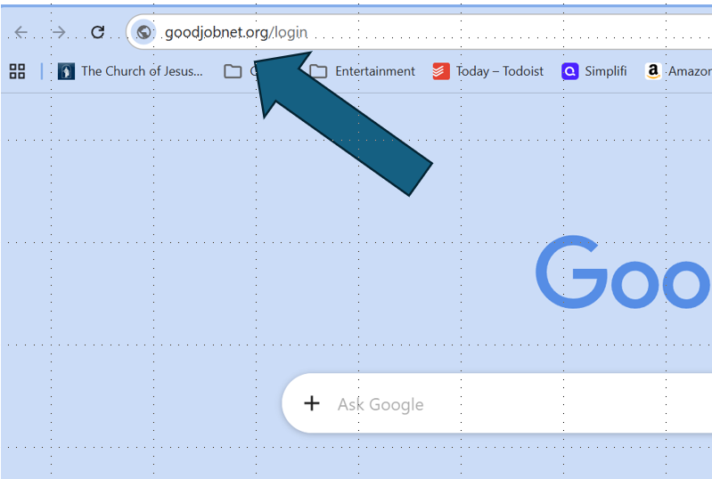
You then enter your username and password to access the Employment Center Dashboard. If you have not yet established an account, click on the link at the bottom of the Login page.
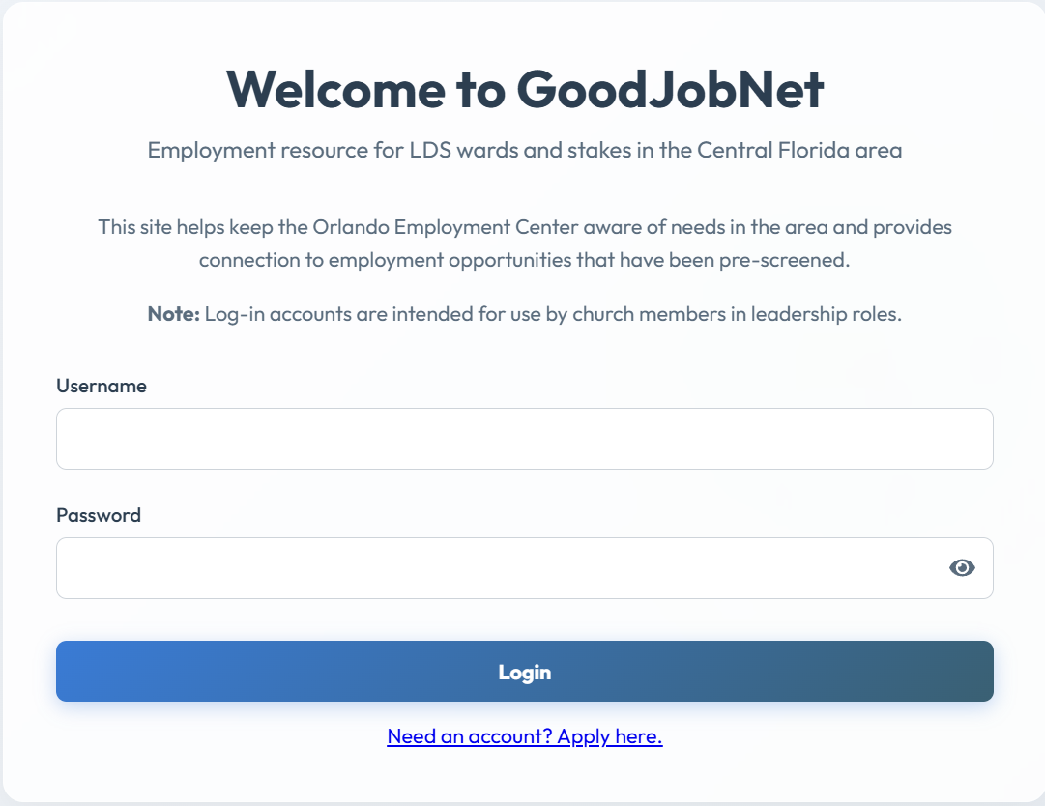

This is the Employment Center Dashboard that is intended for use by volunteers at the Orlando Employment Center.
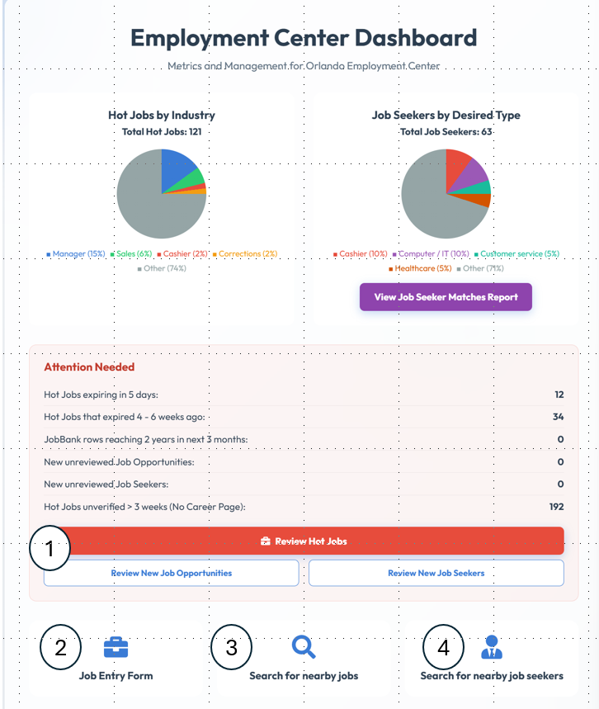

Item 1: Review Hot Jobs. This helps maintain a list of potential job opportunities that have been pre-vetted for individuals seeking employment. This involves reviewing career pages for different employers to determine what positions are posted for new hires.

There are different categories for Job Verification:
- Jobs expiring in the next five days
- Jobs that have recently expired in the last 4-6 weeks
- Jobs that require phone verification (no career website available)
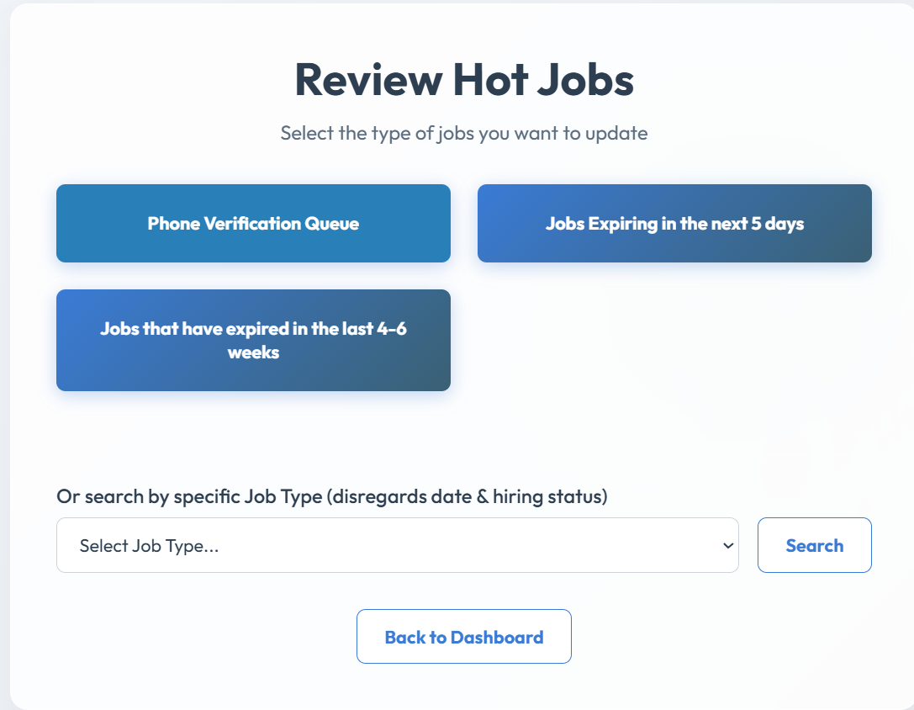
Use this page to revalidate potential job opportunities
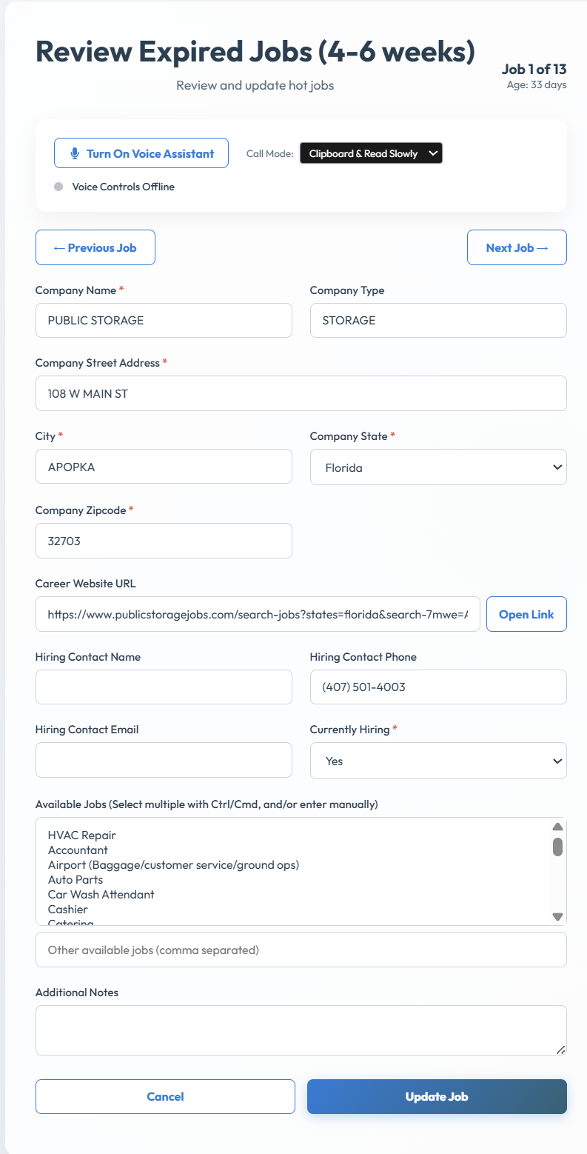

Item 2: New Job Entry Form. Used for entering information for a new job that we want to have available for individuals seeking employment.
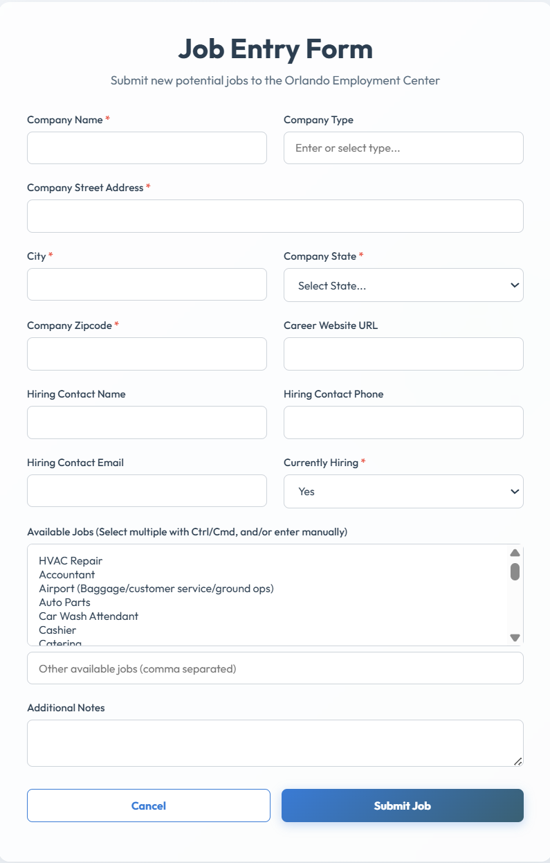
Item 3: Brings up the webpage used for searching for nearby jobs. It is very helpful for those seeking employment to find job opportunities close to where they live.
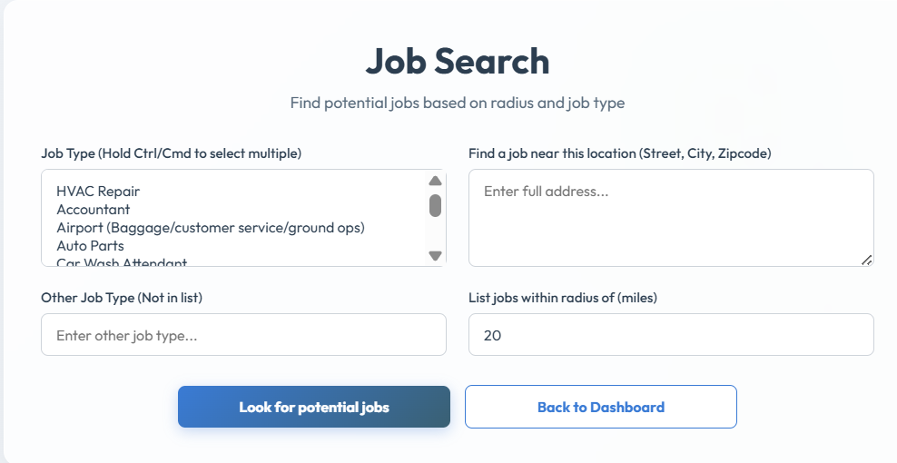

Item 4: Search for nearby job seekers. This is used to help a potential employer find individuals who are seeking a particular job. Very similar to the Job Search window shown above

